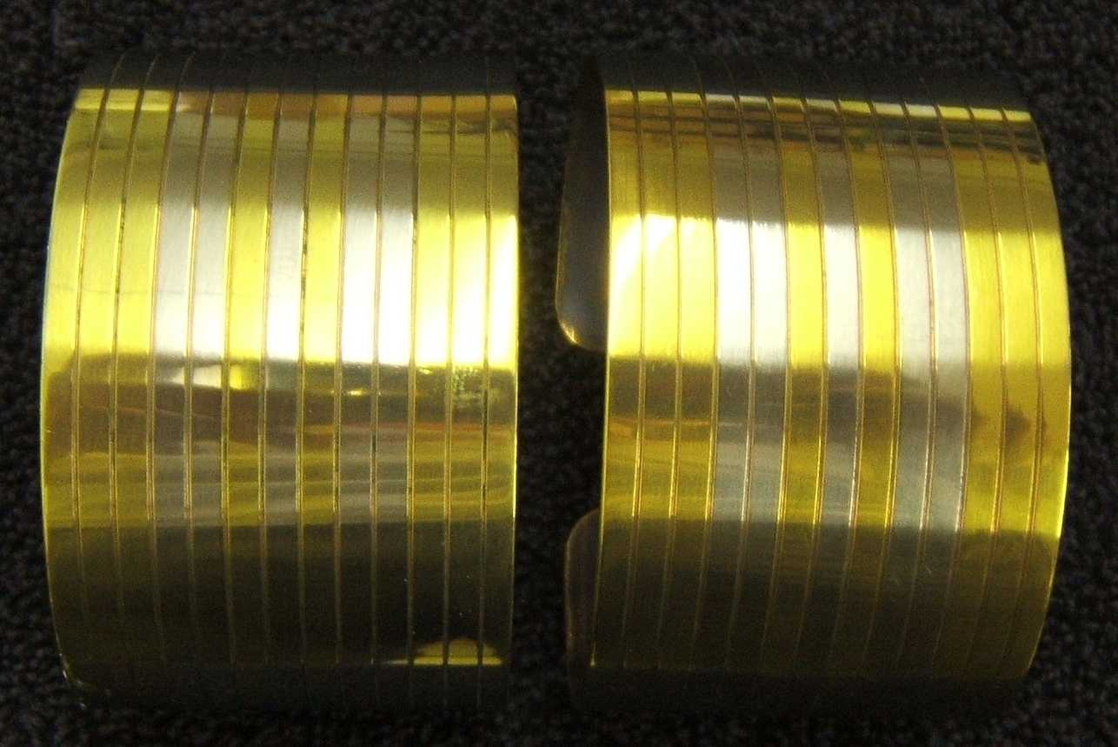

Thought these might be good for your use. Since you never sent me Deeyah’s measurements, I cut one of them very thin (~.5mm) so that it is springy enough to be worn around the bicep or the wrist. Maybe one over the bicep and one on the wrist of the same arm, or on the opposite wrist. May be able to wear either on the bicep.

Titanium hydraulic tubing. Lines cut in .2mm with threading tool. Polished. Masked and anodised gold.

Some of the other stuff I have done for Vic. Have also done other bits, but never got pictures before giving away.
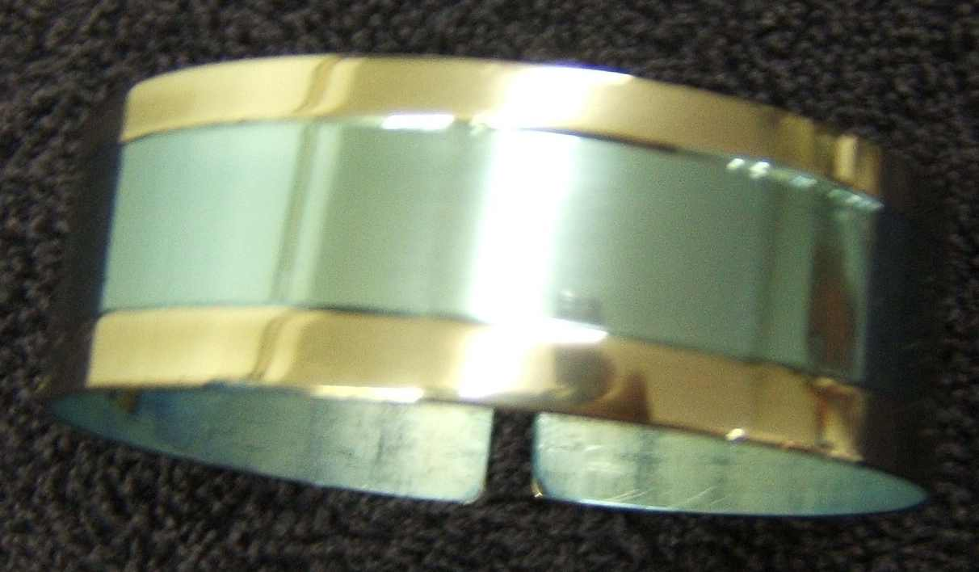
Titanium hydraulic tubing. Polished. Masked and anodised aquamarine..

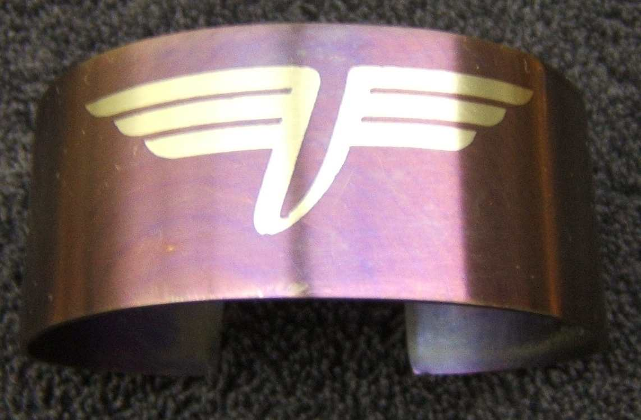
Titanium hydraulic tubing. Brushed and anodised indigo. Mask was a small vinyl cutout I had made when doing a batch of bike graphics. It is the “Flying V” logo I did for the the back of Vicki’s leathers.

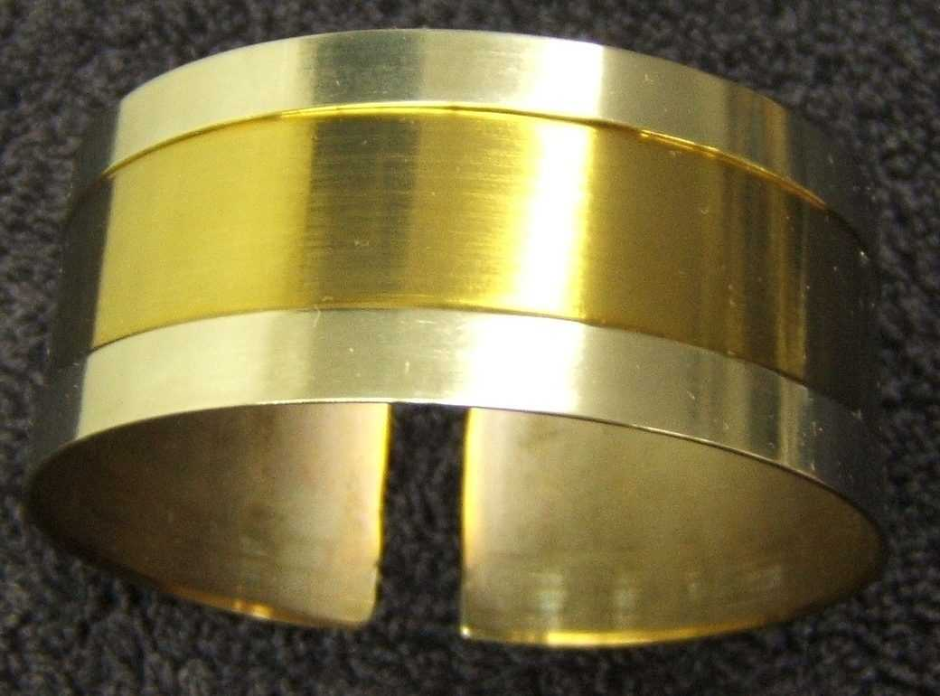
Titanium hydraulic tubing. Polished. Masked outer parts, brushed and anodised gold.

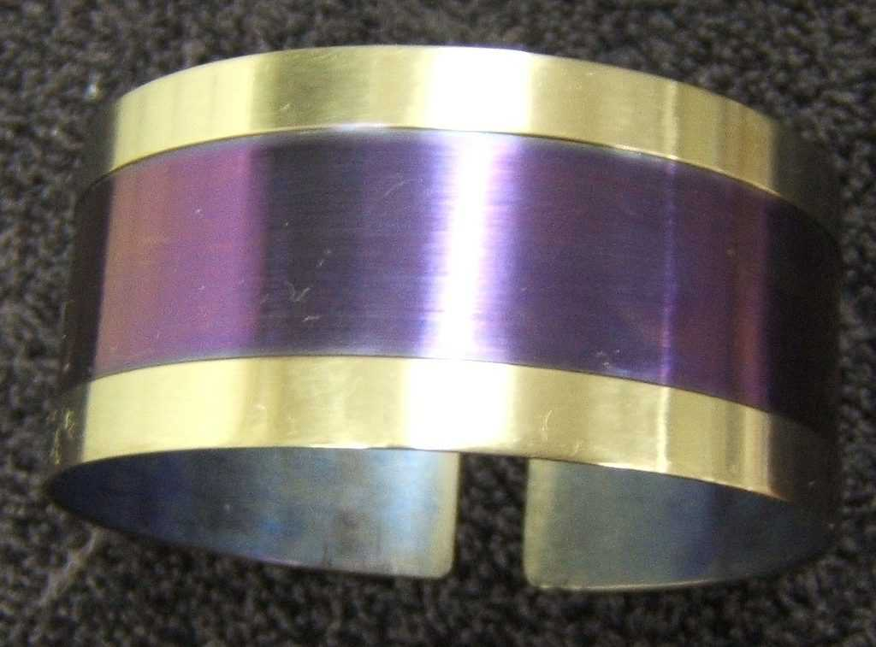
Titanium hydraulic tubing. Polished. Masked outer parts, brushed and anodised indigo.

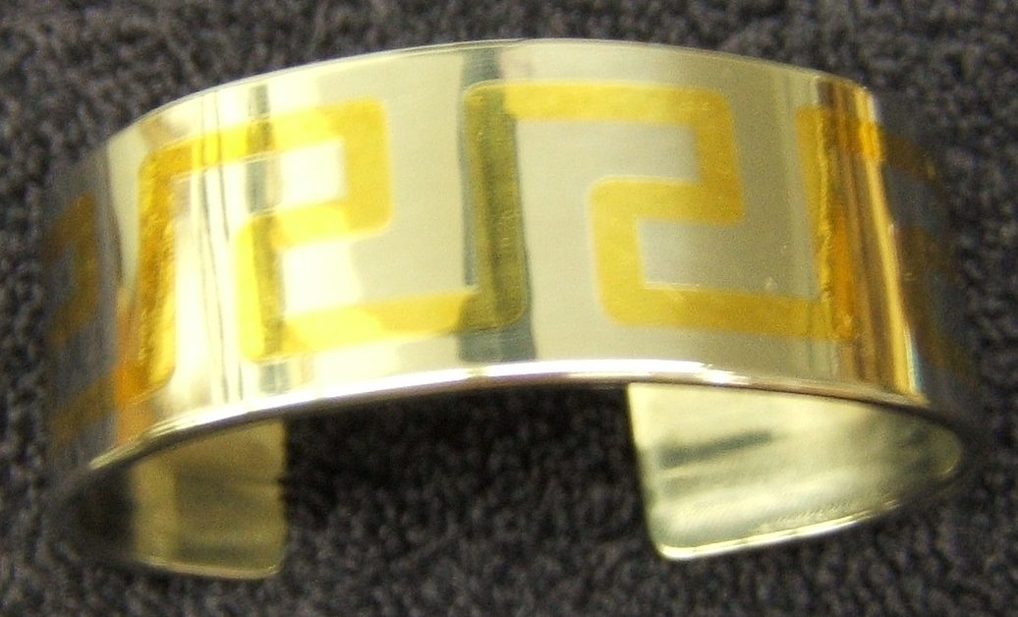
Stainless steel strap that I cut a greek key design into with the mill. Filled with bronze welding and planed off the top. Bent to a bracelet. Kinda heavy.

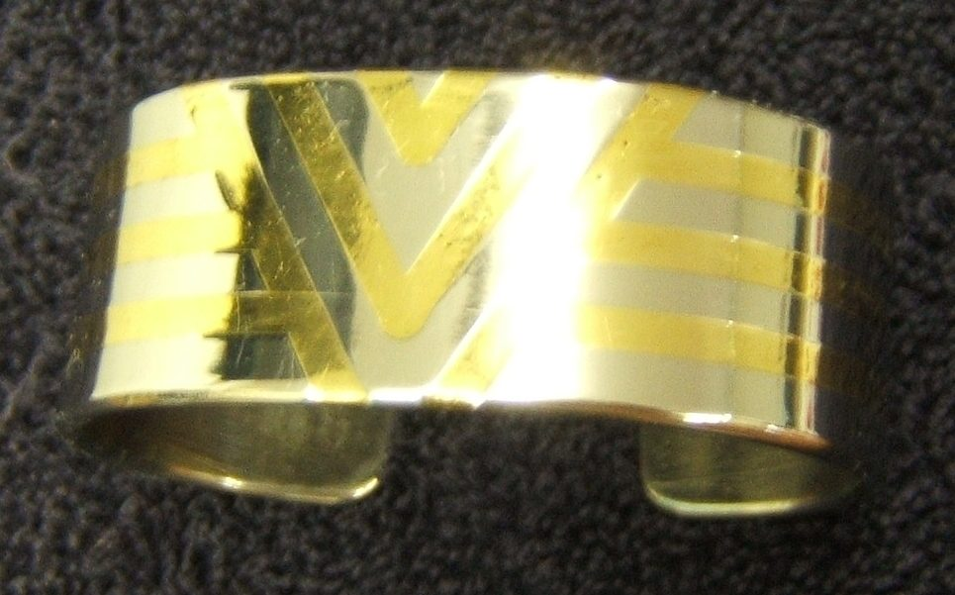
Stainless steel strap that I cut a “V for Vicki” design into with the mill. Filled with bronze welding and planed off the top. Bent to a bracelet. Kinda heavy.

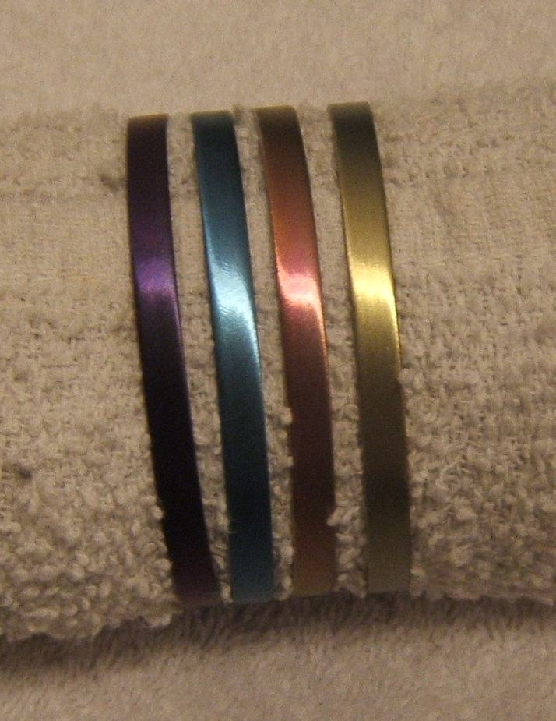

A set of “bangle” bracelets for Joleen. Cutoffs from pipe, deburr edges, brushed finish. High voltage anodize for colour.

Titanium Rings:

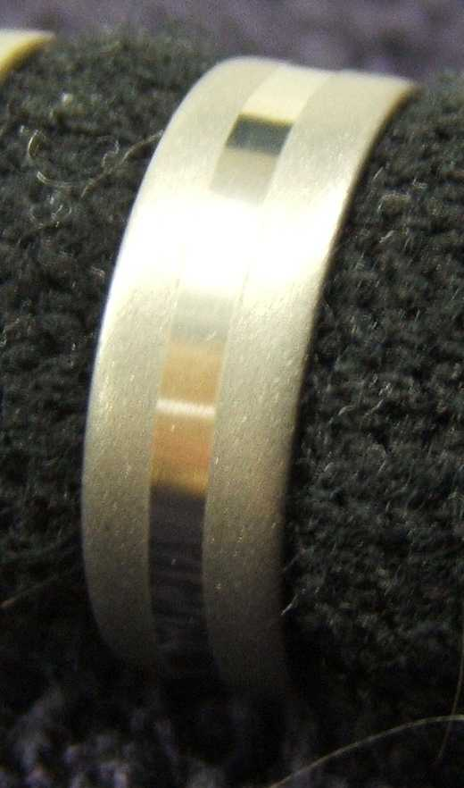
Ring. Cut and bored to size. Polished, then masked the centre section. Beadblasted.

Frosty.

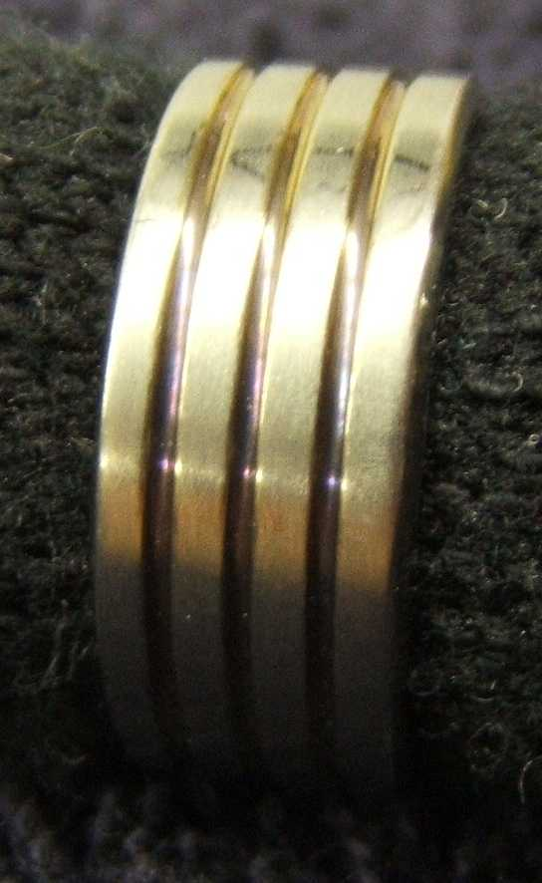
Ring cut and polished. Anodised gold, then polished off the top surfaces to leave only the stripes.

In this photo you can really see the colour changes in the anodised sections. It is refractive, so the different lighting gives it different colour.

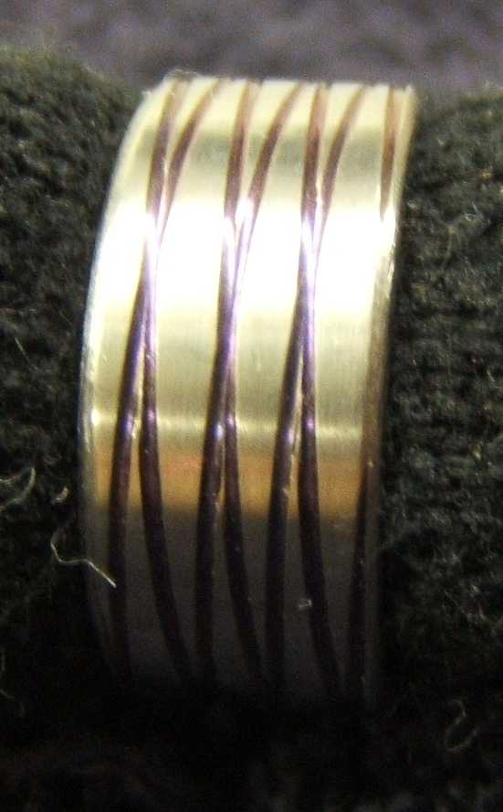
Ring cut and polished. Helix are cut using the threading gears on the lathe. Anodised indigo, then polished off the top surfaces to leave only the stripes.

Double helix, one thread cut in reverse. TiDNA

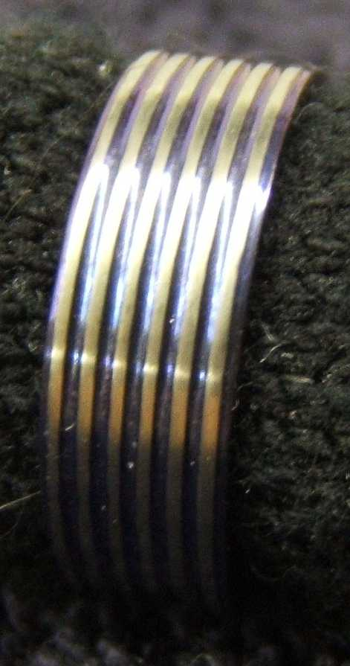
Ring cut and polished. Anodised blue, then polished off the top surfaces to leave only the stripes and edging.

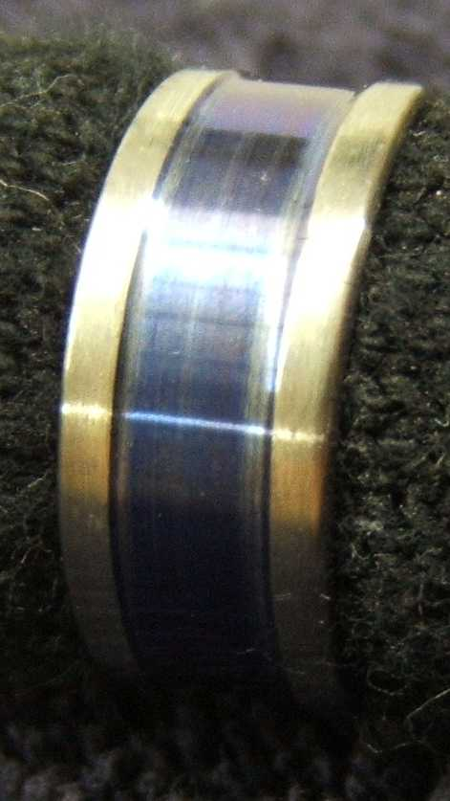
Ring cut and polished. Anodised blue, then polished off the top surfaces to leave only the wide stripe.

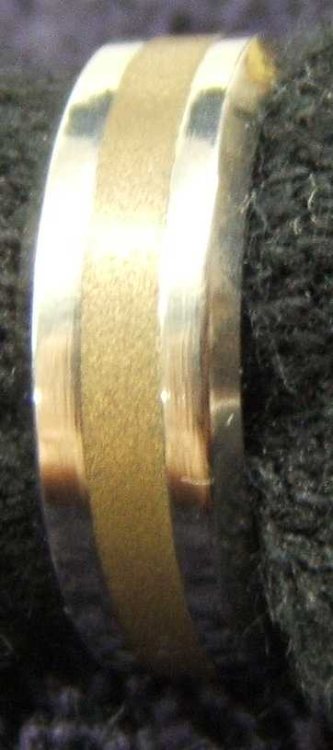
Cut out basic ring and then grooved .75mm deep. Mount ring on a mandrel cut to internal size. Used an epoxy with bronze powder filler, and immersed ring in epoxy. Put in vacuum chamber to remove any air bubbles.

Put mandrel in lathe and cut epoxy down to ring level. Did final cut to outer size, and bevels. Polish.

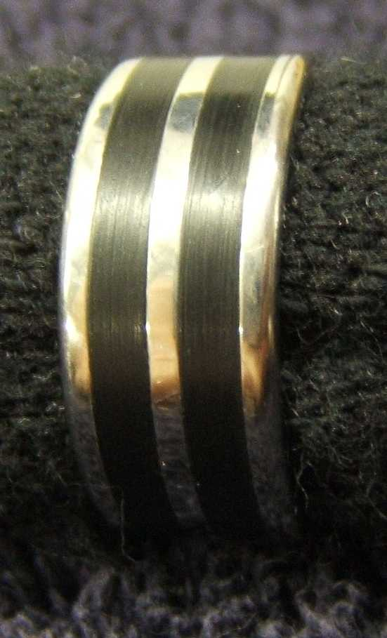
Same epoxy inlay techniques, but used a black dye in the epoxy.

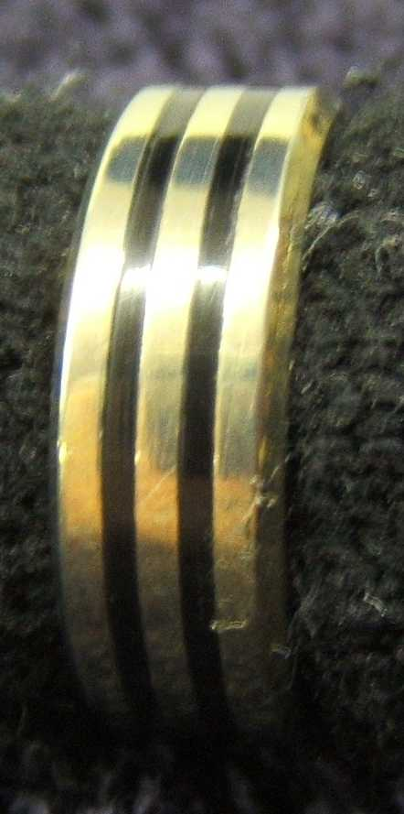
Similar to above, but used a special tool I made to cut only 1mm wide. After polishing, anodised gold.

Made a wedding set like this for a friend. Men’s ring a little wider with three stripes. Were also beveled to give it a more formal look.

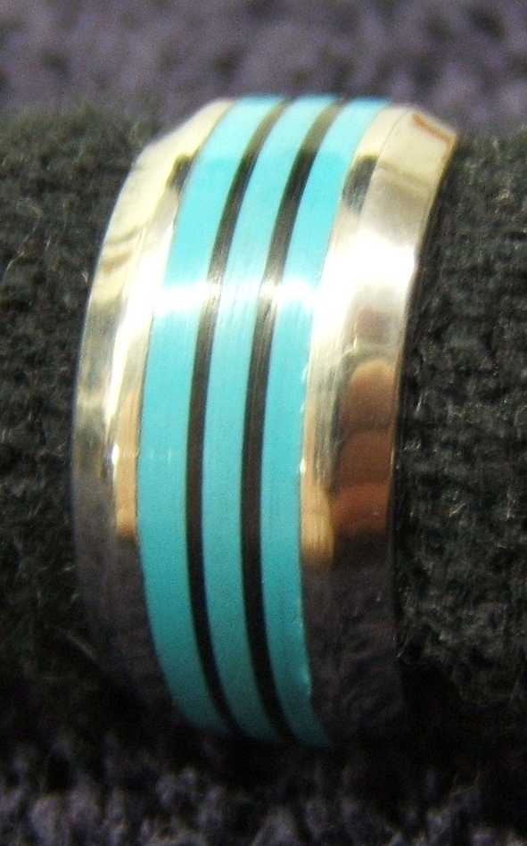
Double dipped – Used epoxy dyes (green, blue, white) to blend a turquoise. Did the normal inlay, then cut into the epoxy and did a second inlay with black since turquoise always has black inclusions. Made this a bit heavier since southwest silverwork usually is.
Anasazi Moderne

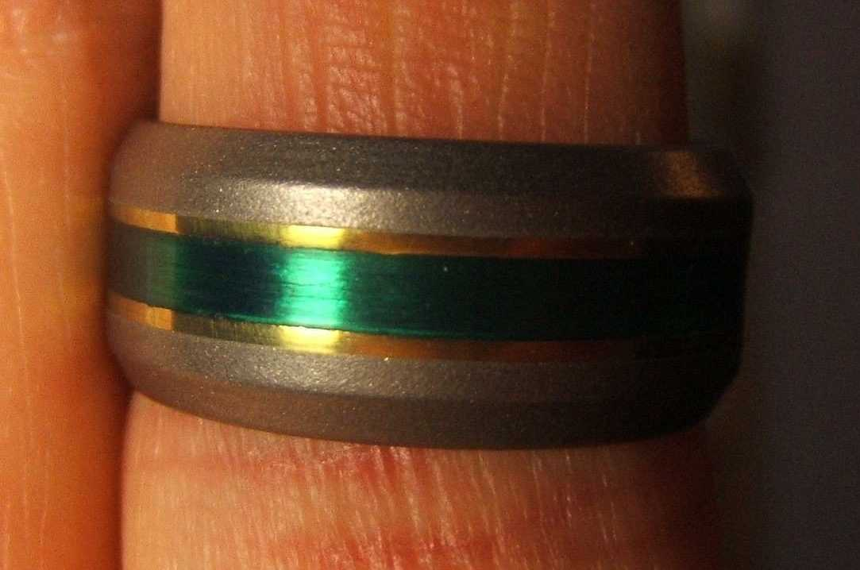
Epoxy inlay. The cutout was striated with a file for reflectivity. The epoxy was translucent green. Final polish, then tape off the epoxy and a small border. Beadblast the rest for the satin finish.

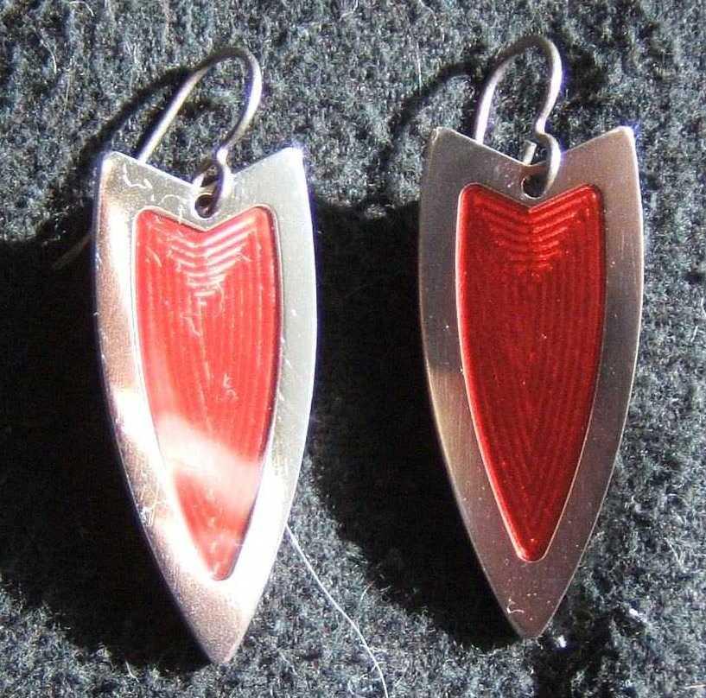
Earrings machined with mill from Ti. The pocket is done at higher feed and slower feed to get the pattern that reflects the light. Vacuum filled with red tinted epoxy. Mirror finish.

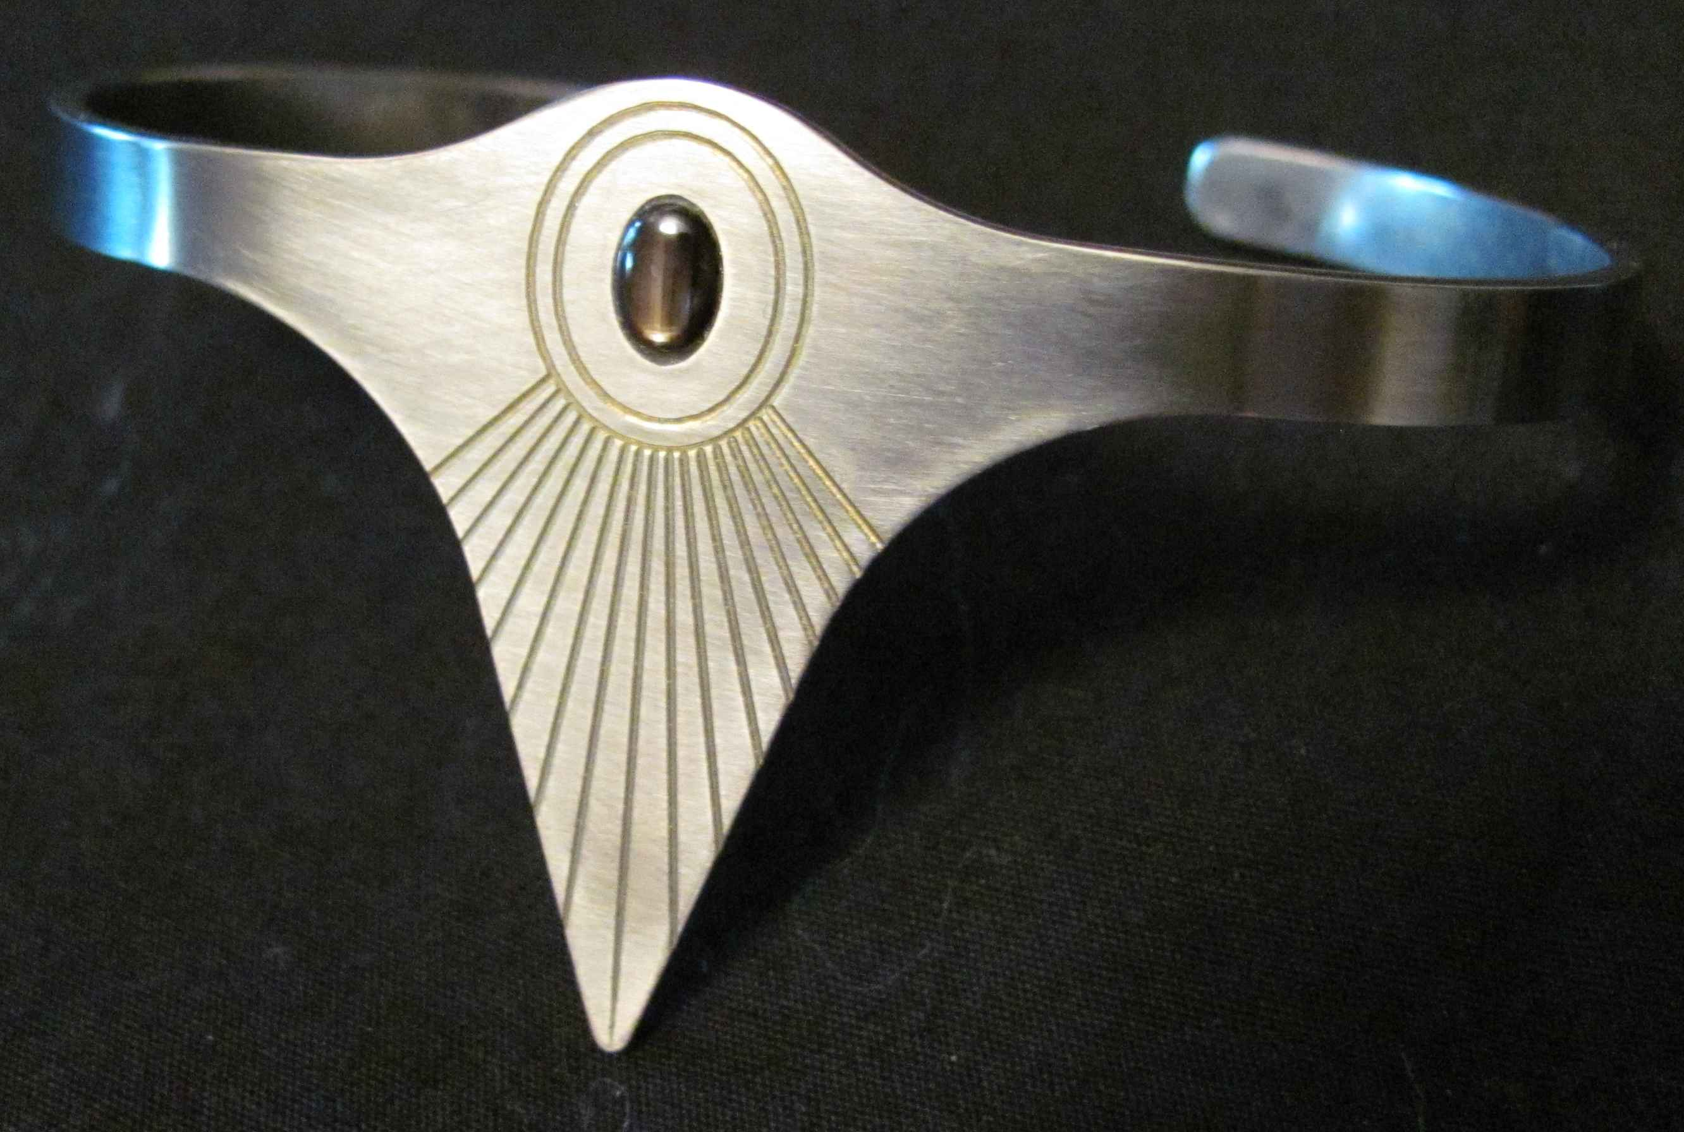

Inspired by the Egyption Aten design from the Amarna period. Brushed titanium with engraving anodised gold. Stone is slightly recessed star sapphire.

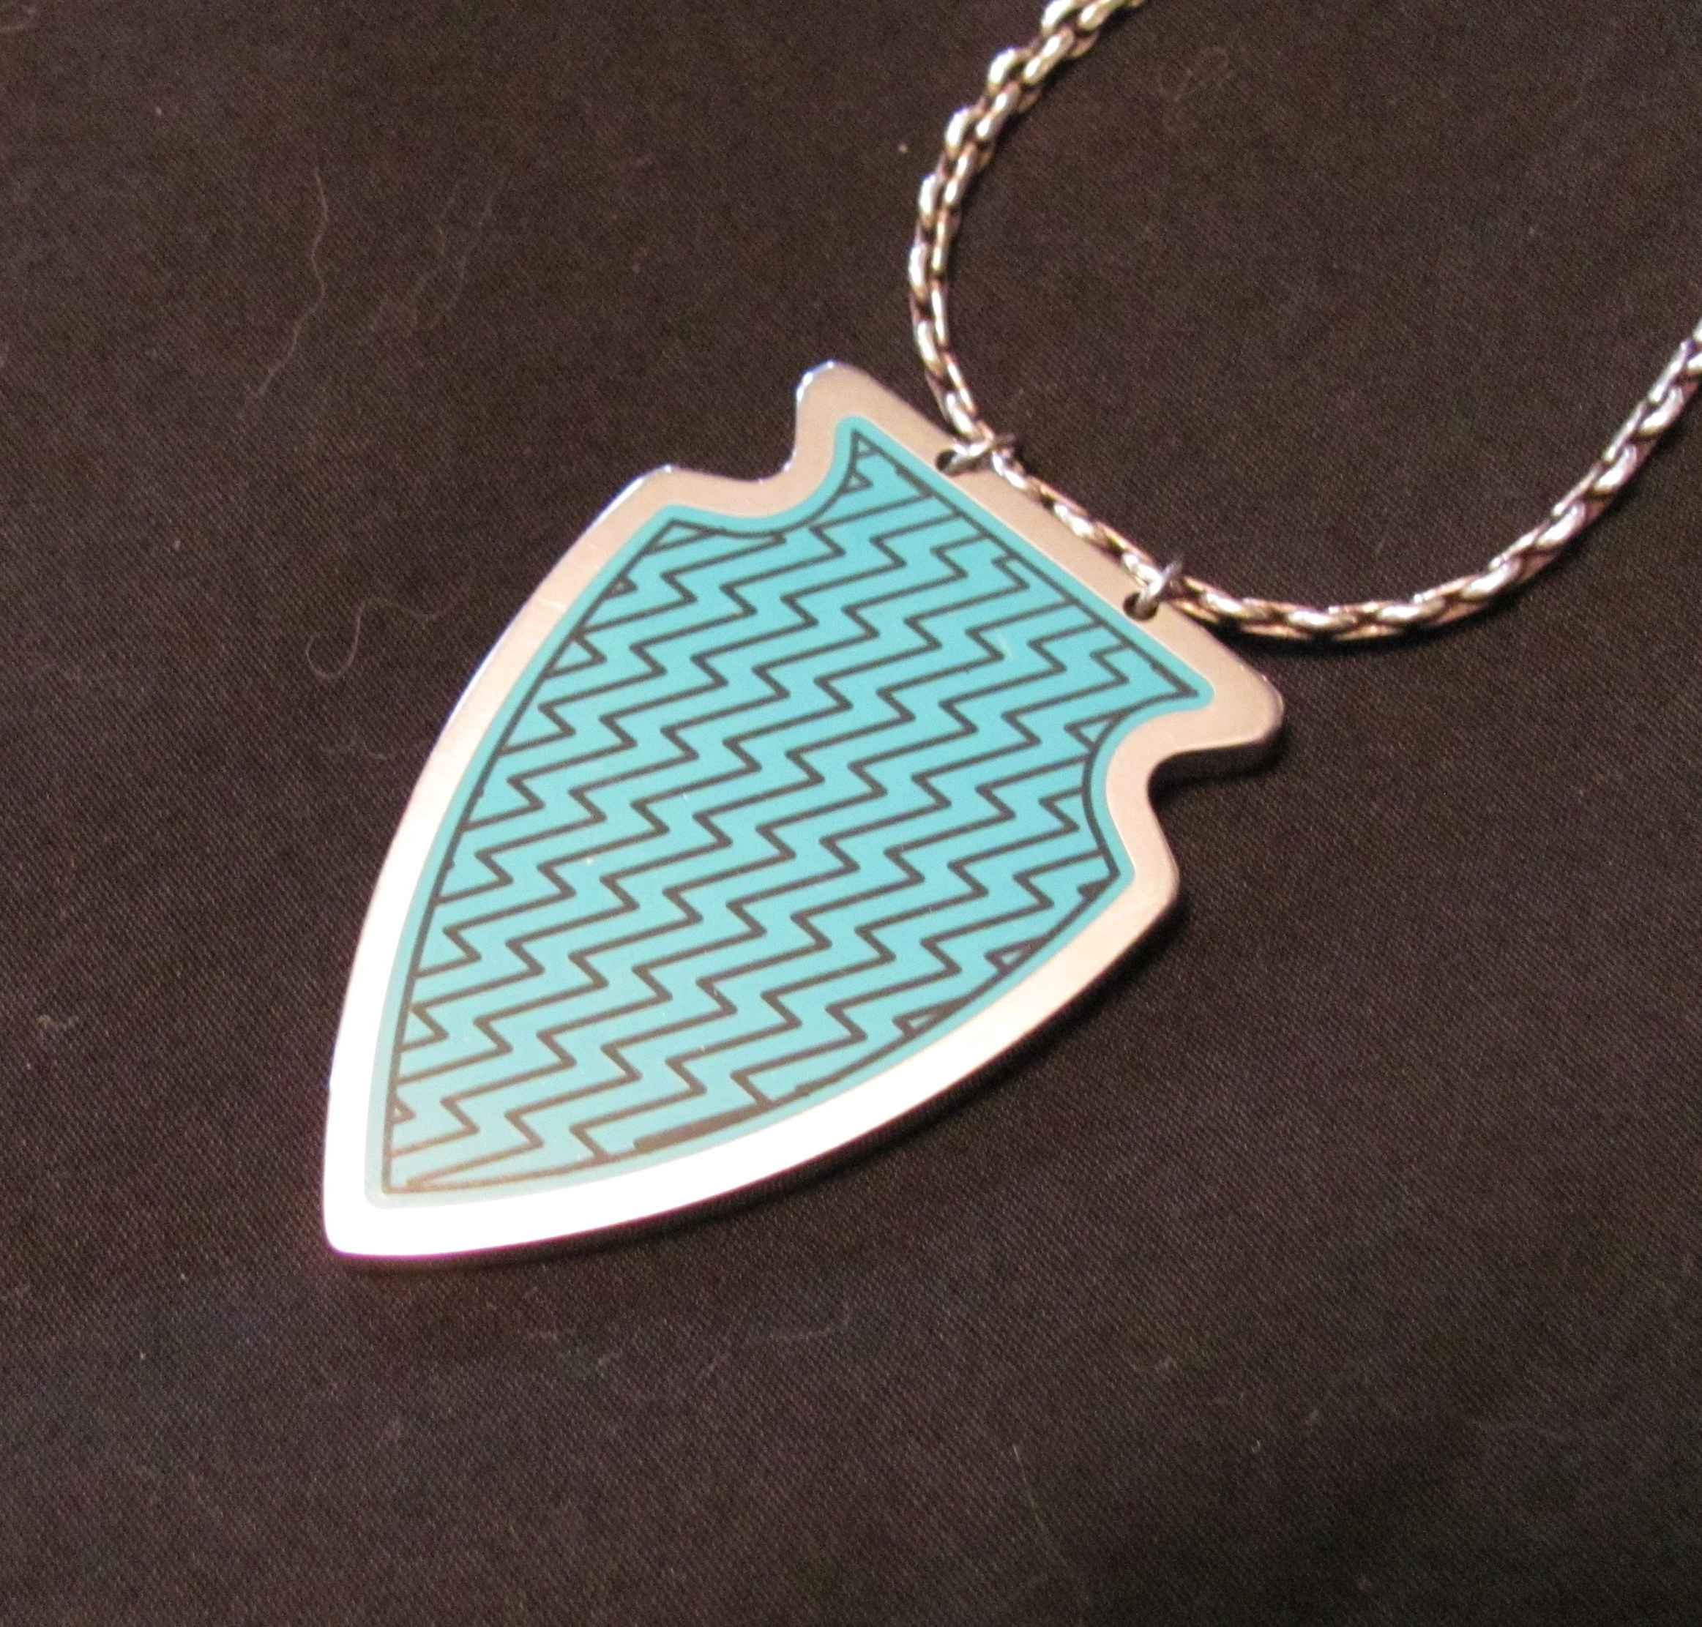
Stainless steel pocketed and filled with turquoise coloured epoxy. Engraved the border and “lightning bolt” lines, then filled with black epoxy for contrast. Final polish, and I cheated and bought the chain.

